   

Marker 1 Marker 2 Marker 3 Marker 4

   

Marker 100 Marker 200 Marker 300 Marker 400

  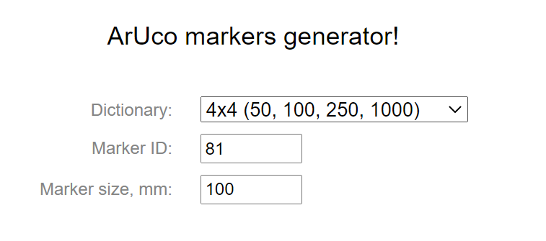

Marker 35 Marker 81

Marker 1 (3.20cm)

|  |  |  |  |  |
| --- | --- | --- | --- | --- |
|  | 10cm |  |  |  |
| Marker 1(3.20cm) |  | Marker 2 |  | Marker 3 |
| 7cm |  |  |  |  |
|  |  |  |  |  |
| Marker 100 |  | Marker 200 |  | Marker 300 |

